**TRIPLE THREAT +1**

**ADD USER FROM ADMIN:**

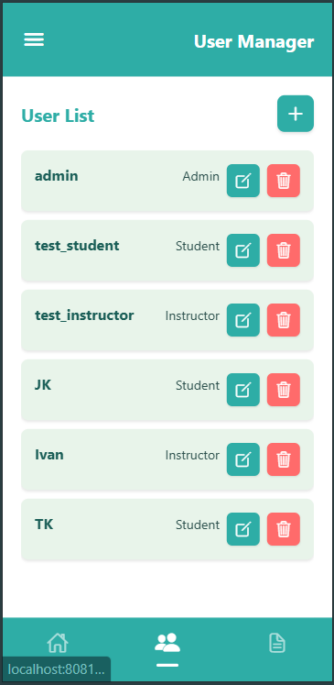

**ADDING A NEW USER**

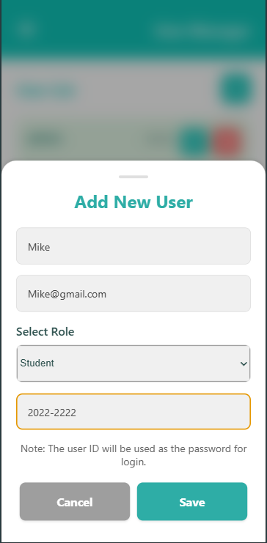

**SUCCESS ADD**

